# -*- coding: utf-8 -*-

"""

Created on Thu Apr 19 00:31:27 2018

@author: neera

"""

#import libraries

import numpy as np

import matplotlib.pyplot as plt

import pandas as pd

# importing our csv dataset

mydata=pd.read_csv('classification_problem_Full.csv')

X=mydata.iloc[:,[0,1,2]].values

y=mydata.iloc[:,[3]].values

# splitting data into training and testing data

from sklearn.cross_validation import train_test_split

X_train, X_test, y_train, y_test = train_test_split(X,y, test_size=0.25, random_state=0)

# Feature scaling

from sklearn.preprocessing import StandardScaler

sc=StandardScaler()

X_train=sc.fit_transform(X_train)

X_test=sc.transform(X_test)

#Classification algorithm area

from sklearn.naive_bayes import GaussianNB

classifier=GaussianNB()

classifier.fit(X_train,y_train)

**Output:**

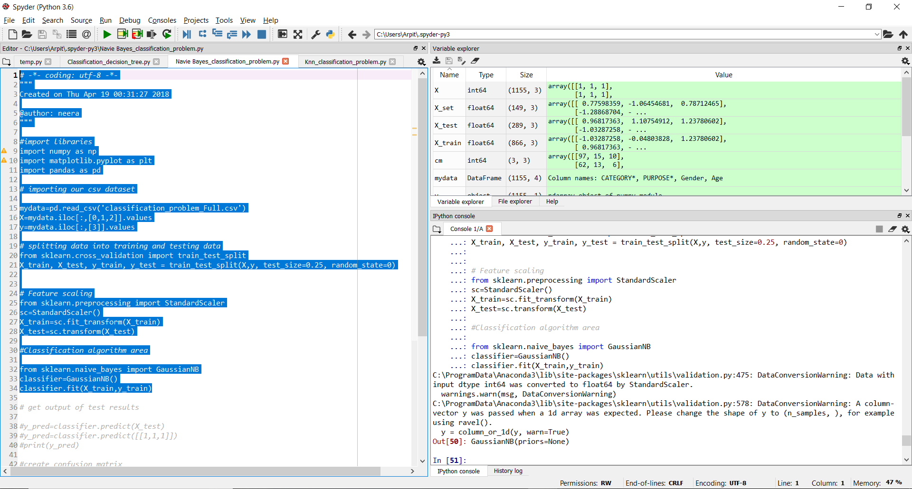

**From Weka:**